**Performance Metrix for classification.**

1. Confusion matrix
2. Accuracy
3. Precision
4. Recall
5. F-Beta Square

**Confusion matrix:**

The confusion matrix can be explained by studying the graph below.

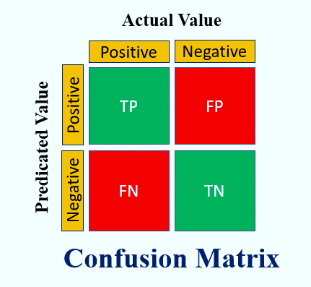

**Accuracy:**

The accuracy function will predict the overall performance of the model.

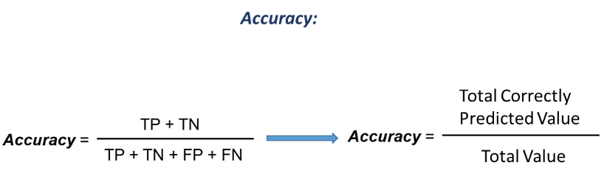



**Precision**

When It is important **minimize** “**false positives**”, especially in sensitive domains where false negatives are less of a concern compared to false positives.

High Precision means that the model is effective where we want to minimize “**false positives**”.

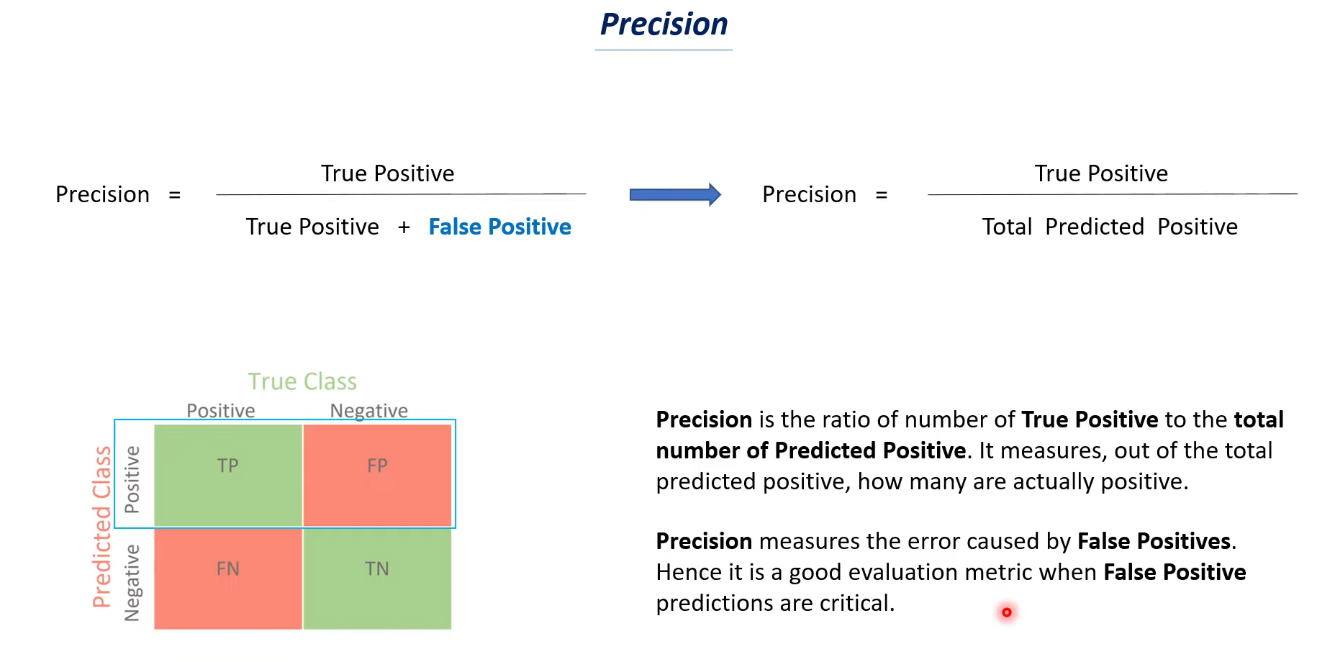





Example:

**Face recognition:**

If a mobile face detection app incorrectly identifies a person's face as the rightful owner, it may unlock the mobile device and grant unauthorized access to sensitive information. This is a serious concern, as it compromises the security and privacy of the device owner.

In the case of a mobile face detection app, false negatives are less of a concern compared to false positives because, if the rightful person's face is incorrectly identified as negative, they can simply retry or use an alternative authentication method like a PIN to unlock the mobile device.

**Email classification to Spam:**

In this case, let's focus on the false positives. The model predicted 20 instances as spam, but in reality, they were not spam. These could be legitimate emails that were wrongly classified as spam.

False positives can have negative consequences as they can lead to important emails being sent to the spam folder or filtered out, causing inconvenience or missed opportunities for users.

In the case of spam detection, false negatives are generally less of a concern compared to false positives. If a spam message is incorrectly classified as not spam (a false negative), users have the option to manually tag that specific email as spam, thus correcting the misclassification.

**Recall:**

The recall is particularly useful in situations where it is important to **minimize** **“false negatives”**. For example, in medical diagnostics, it is crucial to identify as many true positive cases as possible, even if it results in a higher number of false positives. In such cases, recall serves as a valuable metric to evaluate the model's ability to identify positive instances.

High recall means that the model is effective when we want to minimize **“false negatives”**.

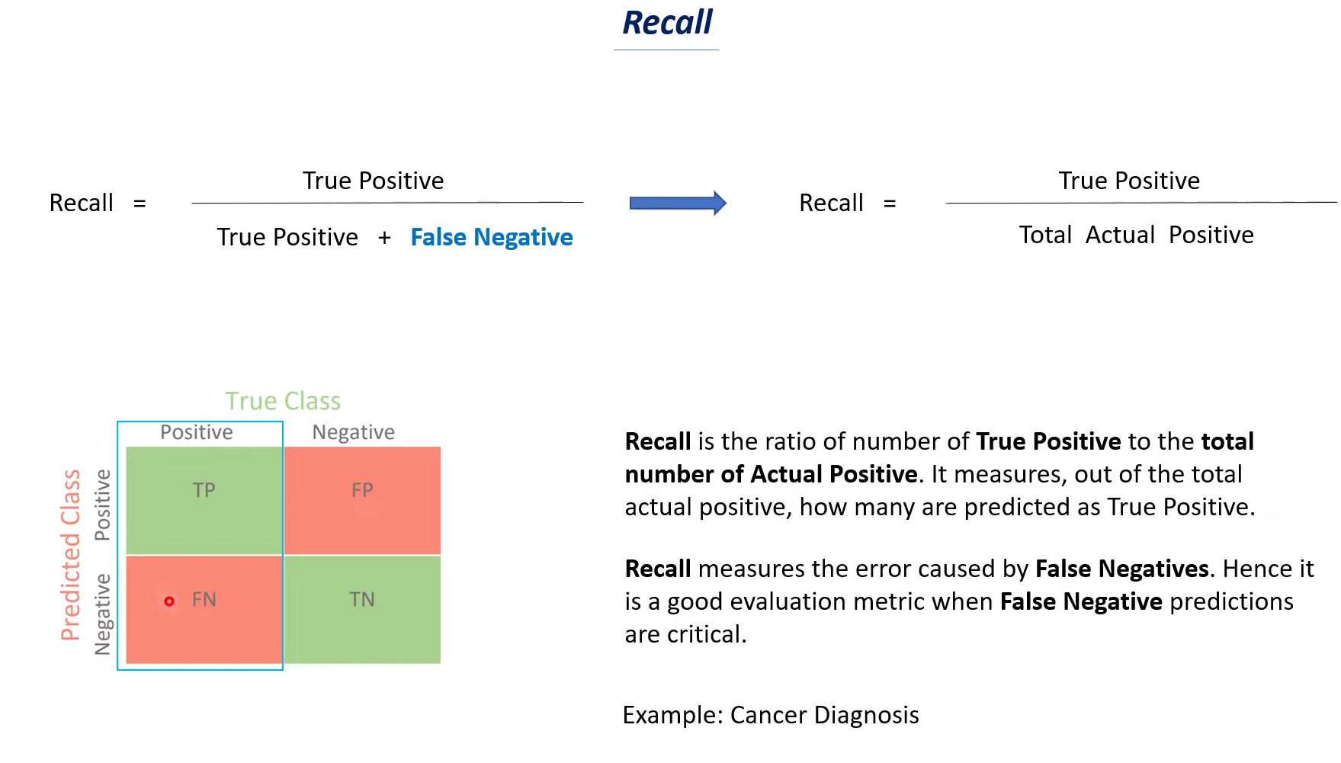





**F-measure:**

If both True positive and False Negative is important.

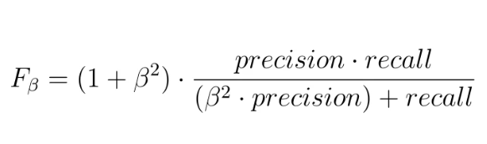

**Example of Precision Recall and F1 Score:**

